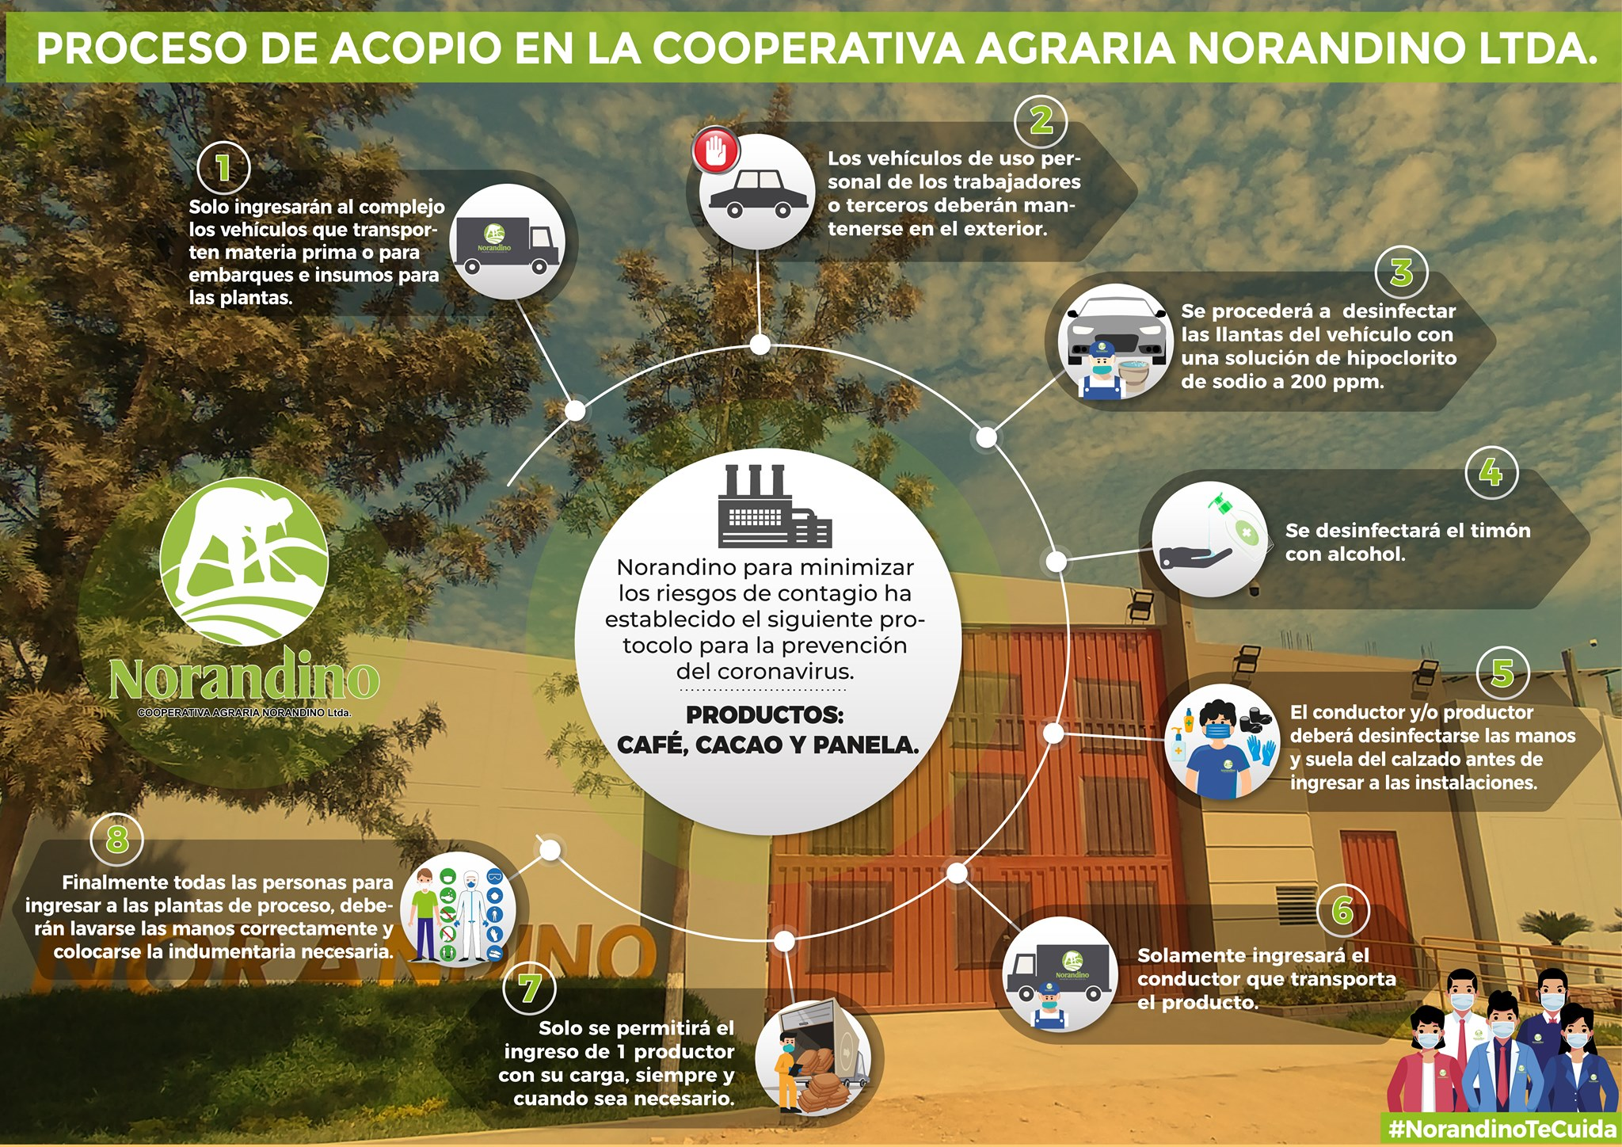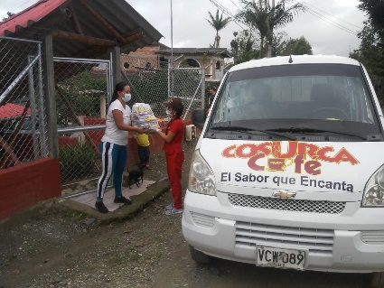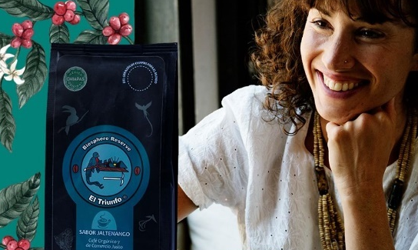
Cesmach, Chiapas, Mexico
Cosurca, Cauca, Colombia
Norandino, Piura, Peru

- Despite the great challenges posed by the COVID-19 pandemic, hundreds of thousands of small producer families and SPP companies are still working to ensure that consumers can continue to enjoy healthy, high-quality products in their homes.
- SPP’s small producers and companies, committed to the environment, health, and sustainability, offer consumers an effective healthy consumption alternative to agro-industrial foods that are destructive to both the planet and health.
- We call on consumers and companies to join a true ecological, sustainable, and healthy fair trade, which satisfies the conscience as well as the palate.

To the public opinion
The COVID-19 pandemic has disrupted the daily reality of almost everyone in the world. Because of the enormous risks to human health, what concerns us all most is to protect the lives, specifically of vulnerable populations, for which many of us are in voluntary or mandatory confinement.

However, confined people still need food and millions of small producers continue to produce to be able to satisfy this need with healthy and quality food. Furthermore, small producers' families do not have the option of giving up their work in the fields, because they depend on what they produce every day.

SPP Global has initiated an internal and external communication campaign to communicate the pandemic's impact on the lives of our members, mainly on hundreds of thousands of small producer families grouped in more than 120 democratic organizations in 24 countries in Latin America and the Caribbean, Africa and Asia.

We also want to inform you about the pandemic’s impact on our companies which, together with the small producers' organizations themselves, with a great deal of commitment and dedication, bring our products to consumers in a total of 40 countries.

From the first reports and testimonies of producers and SPP companies, we share with you the news we have, which are a combination of difficulties, response actions and solutions found in the various organizations of small producers and SPP companies in the world. We also call on you, on behalf of the producers and SPP companies, to continue consuming our products:

- The rapid spread of COVID-19 and the containment and control measures of the different government agencies have caused producers and SPP companies to face multiple problems and obstacles, among others:
  - Legal and voluntary restrictions for producers and workers to move to production and work sites, putting production itself at risk in terms of volume and quality.
  - Lack of vehicle availability to transport products from the production units to storage and processing plants, both our own and those of third parties
  - Lack of availability of personnel and official authorization permits for processing and export activities.
  - Lack of access to timely financing for the collection of products delivered by small producers, due to the lack of operation of national and international credit agencies.
  - Lack of timely access to equipment for people to work according to health protocols.
  - Lack of access to, and high costs of, inputs and tools needed for organic production.
  - Lack of availability of labor for regular harvesting work, as in the case of SPP coffee, cocoa, and bananas.
  - Cost of workers hired for the crops is almost doubled, between the cost of the day's wage and the additional costs of health safety measures and equipment.
  - Impossibility of carrying out productive technical accompaniment in the field and practical training.
  - Communication and coordination problems of in small producers’ democratic organizations of, given the limited possibility of using electronic means.
  - Strong decrease in purchasing power of small producer families, due to the shortage of basic food basket items.
  - Lack of access to government support for people who lose their income causes the percentage of poor people to increase in countries where numbers were already high, between 40 and 80 per cent.
  - Lack of access to sufficient medical services in quantitative and qualitative terms causes people in many rural populations to close their community borders, in order to avoid any contagion.
  - Logistical problems for timely distribution of highly perishable products in final consumer markets, as in the case of bananas and other fresh fruits.
  - Temporary suspension or decrease of contracts for producers
  - Cancellation of orders by final sales outlets, due to temporary closure or restructuring, and in the case of small businesses, possible permanent closing.
  - Given the uncertainty of consumer behavior in the different phases of the crisis, it is impossible to carry out adequate planning of the business cycle.
  - The demand for high quality products, particularly in the case of coffee, has decreased in some countries, because its consumption was concentrated in cafeterias and restaurants specializing in gourmet consumption culture.
- In response to this problem, small producers' organizations and SPP companies are carrying out the following actions:
  - New work and organizational regulations had to be developed and implemented quickly to protect the health of small producer families and workers.
  - Multiple adjustments have been made to the production and processing processes, ensuring a healthy environment for producers, workers, and consumers.
  - Educational campaigns have been designed and initiated to disseminate safety measures to avoid the risk of contagion in the communities surrounding SPP producers' and companies' organizations and consumers.
  - Both producer organizations and SPP companies have carried out actions to support the livelihood of families in confinement, both producers and workers. In countries where there is no government emergency support, this support has been vital.
  - Great management efforts have been made to ensure that production, processing, and marketing activities continue to be considered as necessities, thus obtaining the necessary permits and safeguards to be able to continue producing, processing, delivering and exporting production.
  - The organizations' representatives, despite having their offices closed, are in constant communication with their clients to ensure timely fulfillment by both parties of the agreed business plans.
  - In many small producer organizations, it has fortunately been possible to restart production and primary processing activities, applying all health safety protocols prescribed for the food sector, once the necessary permits have been obtained.
- Small producers’ cooperatives and SPP companies are also confronted with new market realities. Although these are still unpredictable trends, they are having an impact on the lives and ways of working of producers and trading companies:
  - Since the crisis caused by COVID-19, there is evidence of changes in consumption patterns. In most countries, household spending is generally reduced and concentrated on necessities.
  - While there is a new trend away from luxury products, there is also early evidence of increased investment in organically and ecologically produced healthy food.
  - Consumers also seem to be more interested in consuming local or national products, due to their greater availability, and for solidarity, ecological and economic awareness reasons.
  - A new home food and beverage preparation culture is flourishing. We are confident that this trend will lead to a greater awareness of the origin and quality of products and ingredients.
  - Confined consumers also seem to be unwilling to forego certain consumer pleasures. Beer and other alcoholic beverage sales have increased. In some countries there is talk of a considerable increase in chocolate consumption.
  - Some studies point to a high probability that these new consumption habits will remain, to some extent, after the pandemic is over.
- As producers and companies of the SPP Family we will be focusing our promotion, awareness and education efforts on strengthening the culture of the integral quality of small producers’ food products and turning final consumers into experts and 'gourmets'.
It is important that consumers realize why it is important to support small producers’ organic production and to support solidarity-based small and medium enterprises to cope with this and possible future pandemics:
  - SPP small producers’ products are produced naturally, without agrochemicals. Healthy food makes people healthier and more resistant to disease. SPP products do not have toxic elements that affect the human immune system.
  - SPP small producers’ products are produced on a small scale, in terms of number of people involved and in extension, so they are not sources of infection as they are large production units with thousands of workers concentrated in closed spaces.
  - Conventional monoculture production, associated with massive deforestation, involves the loss of habitat for many animals, such as monkeys, bears, bats, etc., which promotes cross-species disease transmission. SPP products respect the environment and contribute to biodiversity, conservation, and reforestation.
  - Big companies - both in raw materials production and finished products – tend to pass on to society the problems caused by this type of crises, mainly by staff cutbacks. Unemployment particularly affects countries where there are no strong systems of social protection for workers.
  - Small producer families have historically been marginalized in most countries. They have been displaced by large-scale production, which has caused prices paid to small producers to fall and consumers to pay more for poor quality products, with health impacts, the ravages of climate change and the weakening of local economies.
  - The SPP mission has always been to achieve true fair trade for small producers, i.e. that they have secure access to a market that rewards them for the real value of their work. Today, with the increase in the cost of living and production, it is more necessary than ever to have the solidarity of the world's consumers by paying fairer prices.
  - Small and medium enterprises are engines of local economies. They can help to generate greater economic resilience and local food security for consumers. This pandemic is driving the social movement for 'localization' as opposed to 'globalization'.
  - Companies that work with SPP work first and foremost because of their commitment to small producers, to consumers’ health and to a profoundly sustainable world, far beyond profit maximization.
  - Many of the SPP companies, small and medium, are workers' cooperatives, where their employees are both co-owners, thus sharing risks and benefits.
  - Prices received by producers, under the SPP system, have even doubled the prices of normal commercial market, without affecting prices to consumers. With the SPP system it has been demonstrated that justice can be done in markets.
In the face of the crisis caused by COVID-19, we can say that the alliance between small producers, companies and consumers who are committed and show solidarity has proved to be an extremely powerful protective shield for any crisis we may encounter along the way.
Today, more than ever, we need more people to choose to consume organic products from small producers, both locally and in other parts of the planet, and together we need to become stronger and have better impact and resilience, for the good of the whole world.
The SPP family will welcome you to this world that has proved to be possible.

SPP Global.
Mexico City, MEXICO
April 22, 2020
Contact:
dire@spp.coop / +52-1-55-91976470
Jerónimo PRUIJN, Executive Director, SPP Global
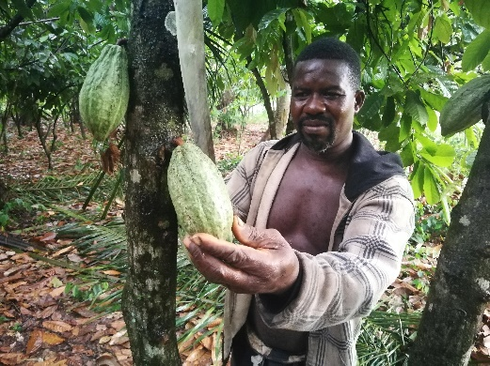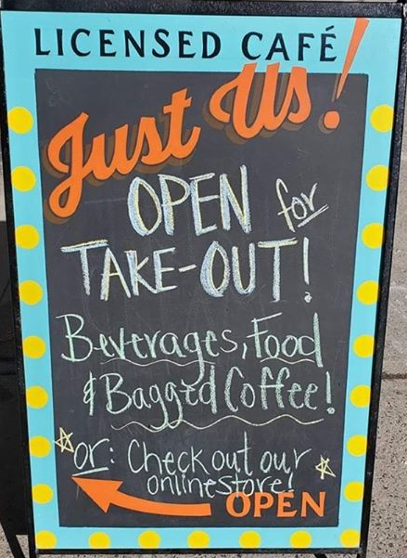
SCEB, Tiassalé, Ivory Coast
Just Us! Coffee, Nova Scotia, Canada
Ethiquable, France
PROCAB, Kpalimé, Togo

